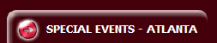
REVIVAL AND FESTIVAL | DATE | TIME | LOCATION
EASTER CONFERENCE | 31 MAR-13 APR 10 | TBD | COPENHAGEN, DENMARK
INDIA CRUSADE AND GLOBAL OUTREACH | TBD | TBD | TENALI INDIA
LIBERIA CRUSADE | 24 NOV-1 DEC 10 | TBD | LIBERIA, W. AFRICA
GHANA CRUSADE | 1 DEC-7 DEC 10 | TBD | GHANA, W. AFRICA
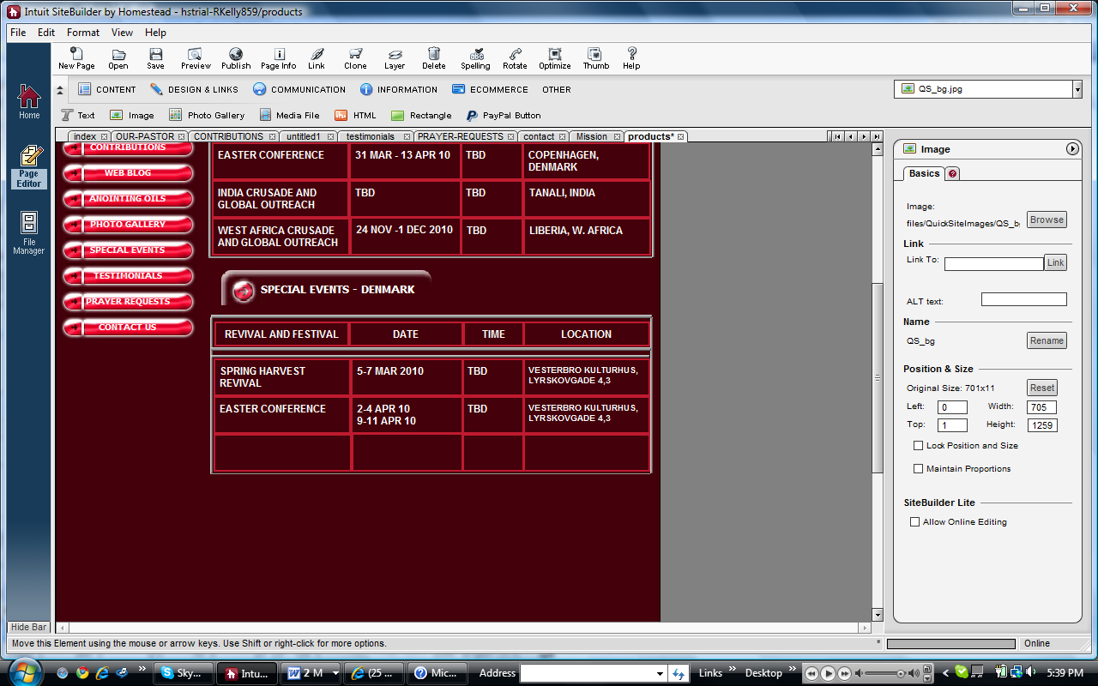
REVIVAL AND FESTIVAL | DATE | TIME | LOCATION
EASTER CONFERENCE | 31 MAR-13 APR 10 | TBD | VESTERBRO KULTURHUS, LYRSKOVGADE 4,3 COPENHAGEN
SPRING HARVEST REVIVAL | 5-7 MAR 10 | TBD | VESTERBRO KULTURHUS, LYRSKOVGADE 4,3
LIBERIA CRUSADE | 24 NOV-1 DEC 10 | TBD | LIBERIA, W. AFRICA
GHANA CRUSADE | 1 DEC-7 DEC 10 | TBD | GHANA, W. AFRICA

